7件在用餐後不要做的事

7 DON’T after MEAL
7在用餐後不要做的事
1.
* Don’t smoke- Experiment from experts proves that smoking a cigarette after meals is comparable to smoking 10 cigarettes (chances of cancer is higher).
*不要用餐後抽煙–專家的實驗證實用餐後抽煙比一般時間抽10根香煙有更高的致癌機率。
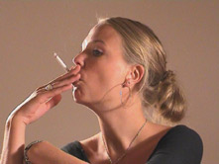

用餐後不要做的事

2.
* Don’t eat fruits immediately – Immediately eating fruits after meals will cause stomach to be bloated with air. Therefore take fruits 1-2 hours after meal or 1 hour before meal.
*用餐後不要立即吃水果–用餐後立即吃水果將導致胃部因空氣而腫脹。
因此在用餐後的2小時或是用餐前1小時吃水果是比較理想的。
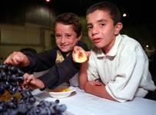

* Don't eat fruits immediately
3.
* Don’t drink tea – Because tea leaves contain a high content of acid. This substance will cause the Protein content in the food we consume to be hardened thus difficult to digest.
*不要在用餐後喝茶–因為茶葉通常含有高酸性。這種酸性物質將導致我們所攝取食物中所含的蛋白質變硬，因此會比較難消化。
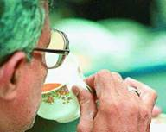

* Don't drink tea
4.
* Don’t loosen your belt – Loosening the belt after a meal will easily cause the intestine to be twisted & blocked.
*用餐後別鬆開你的腰帶–用餐後立即鬆開腰帶將讓你的腸子容易糾結和阻塞。
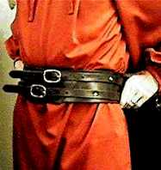

*Don't loosen your belt
5.
* Don’t bathe – Bathing will cause the increase of blood flow to the hands, legs & body thus the amount of blood around the stomach will therefore decrease. This will weaken the digestive system in our stomach.
*不要在餐後洗澡–洗澡時會使得血液流向手、腳和我們身體的其他部位，因此會減少胃部中的血液量，這將會使得我們胃部的消化能力變差。
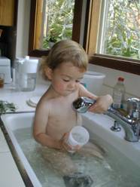

*Don't bathe
6.
* Don’t walk about – People always say that after a meal walk a hundred steps and you will live till 99. In reality this is not true. Walking will cause the digestive system unable to absorb the nutrition from the food we intake.
*飯後不要散散步–大家總是說"飯後走100步可以活到99歲"。但是那個觀念是錯誤的，用餐後的走動將使我們的消化系統沒有足夠能力從我所攝取的食物中吸收足夠的營養。
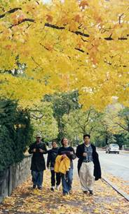

*Don't walk about
7.
* Don’t sleep immediately – The food we intake will not be able to digest properly. Thus will lead to gastric & infection in our intestine.
*用餐後不要立即睡覺–這樣我攝取的食物將沒有辦法得到適當的消化，因此可能導致胃部和腸部的感染。
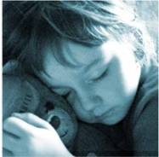

*Don't sleep immediately
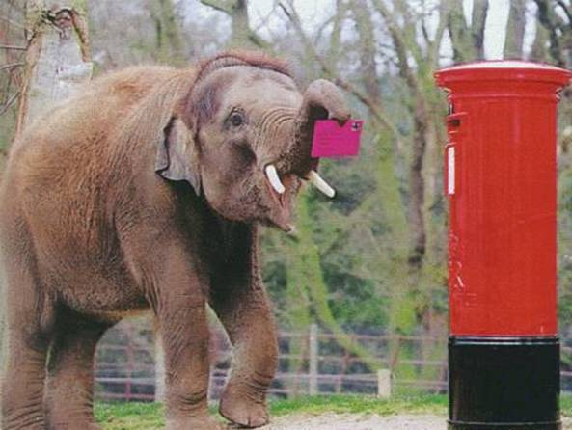

* Don't forget to forward the e-mail to others - If you forget to forward the e-mail to others, your friends may never know the information.
*別忘記將這封信件轉寄給你的好朋友-如果你沒有轉寄的話，他們永遠不會知道這些資訊

