心臟病發作與喝溫開水

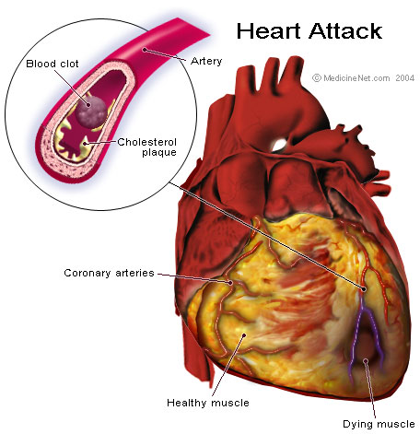
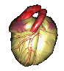
The Chinese and Japanese drink hot tea with their meals, not cold water, maybe it is time we adopt their drinking habit while eating.
中國人和日本人吃飯的時候喝熱茶，而不是喝冰開水，
我們應該學習中國人和日本人的飲食習慣。
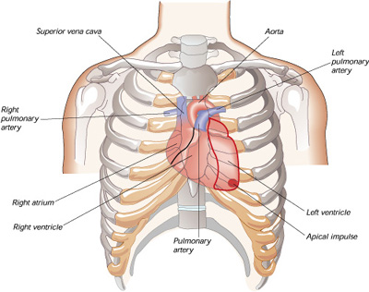
It is nice to have a cup of cold drink after a meal.. However, the cold water will solidify the oily stuff that you have just consumed. It will slow down the digestion. Once this 'sludge' reacts with the acid, it will break down and be absorbed by the intestinefaster than the solid food. It will line the intestine. Very soon, this will turn into fats and lead to cancer. It is best to drink hot soup or warm water after a meal.
吃過飯之後喝一杯冰冷的飲料的確很舒服，然而，冷開水會使你剛剛吃下肚的油膩膩的食物凝結在一起，而且會使胃腸的消化作用變慢，一旦這一大坨像爛泥的東西碰到胃酸，就會分解而很快地被腸子吸引，它會附著在腸壁上，沒多久它就會變成脂肪，而導致癌症，所以說，吃過飯之後最好還是喝一碗熱湯或一杯溫開水。

Common Symptoms Of Heart Attack...
心臟病發作的一般徵兆
A serious note about heart attacks! -! You should know that not every heart attack symptom is going to be the left arm hurting . Be aware of intense pain in thejaw line .

請你特別注意：並不是所有心臟病發作的時候都會左臂疼痛，你倒是要留意你頸項的劇烈疼痛。

You may never have the first chest painduring the course of a heart attack.Nausea and intense sweating are also common symptoms. 60% of people who have a heart attack while they are asleep do not wake up. Pain in the jaw can wake you from a sound sleep. Let's be careful and be aware. The more we know, the better chance we could survive.

心臟病發作的時候不一定會胸口疼痛，而噁心和猛烈的盜汗才是心臟病發作時常見的徵候，有60%的心臟病在睡夢中發作而患者因此一覺不醒，頸項疼痛常常會把你從熟睡中醒過來，所以要特別小心，我們懂得越多，活命的機會就越大。

A cardiologist says if everyone who reads this message sends it to 10 people, you can be sure that we'll save at least one life. Read this & send to a friend.

一位心臟病專科醫生說，如果每一個讀到這個資訊的人都把它轉寄給十個朋友，至少可以救活一個人！

